## **Git**

## **Pre-requisites:**

* Git setup file ' Git-2.35.0-64-bit.exe' setup file must be downloaded from below-
* **URL:** https://git-scm.com/download/win
* User should have administrator rights to install the Git setup file 'Git-2.35.0-64-bit.exe

## **Installation:**

* Log in to the machine where Git Installation will be installed.
* Go to the location where ' Git-2.35.0-64-bit.exe' setup file is downloaded.
* Copy the ' Git-2.35.0-64-bit.exe' setup file.
* Navigate to the specific directory where 'Git-2.35.0-64-bit.exe' will be copied. (C:\Share\Git)
* Double click on 'Git-2.35.0-64-bit.exe'. After that 'Information of GNU General Public License' windows will be opened.

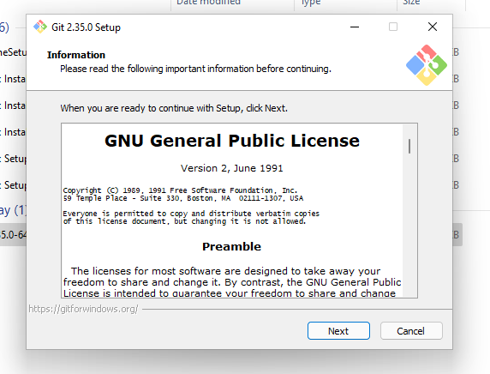

* Click on 'Next' Button. After that 'Select Destination location' windows will be opened.

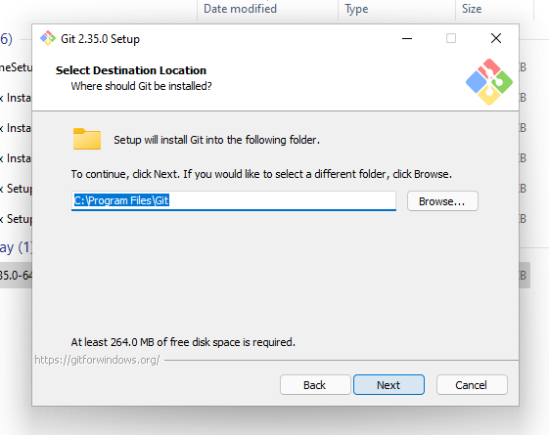

* Click on 'Next' Button. After that 'Select Component' windows will be opened.

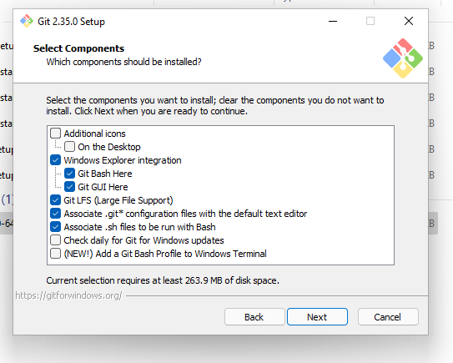

* Click on 'Next' Button. After that 'Select Start Menu Folder' windows will be opened.

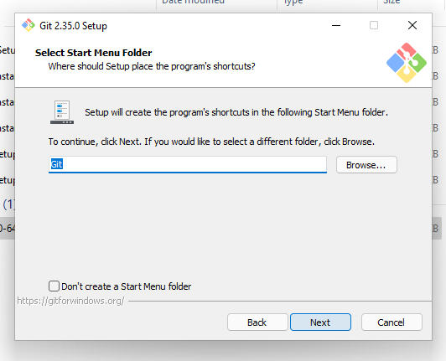

* Click on 'Next' Button. After that 'Choosing the default editor used by Git' windows will be opened.

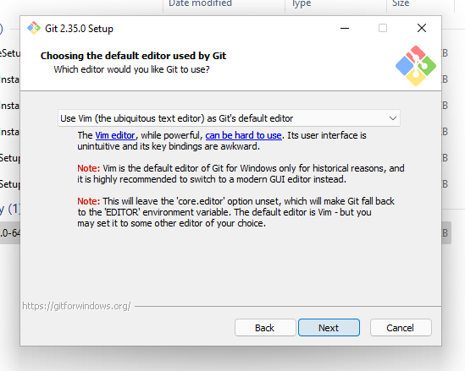

* Click on 'Next' Button. After that 'Adjusting the name of the initial branch in new repositories' windows will be opened.

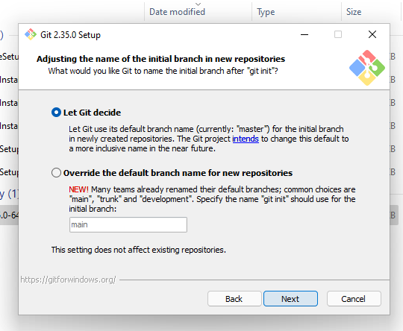

* Click on 'Next' Button. After that 'Adjusting your Path environment' windows will be opened.

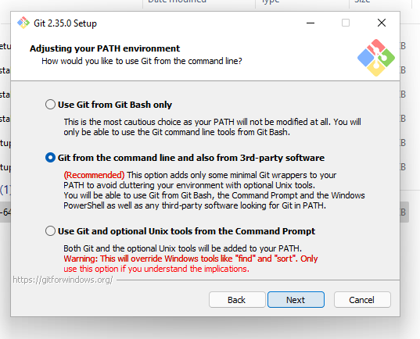

* Click on 'Next' Button. After that 'Choosing the SSH executable' windows will be opened.

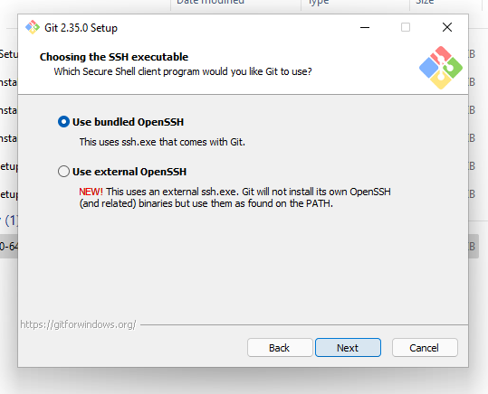

* Click on 'Next' Button. After that 'Choosing HTTPS transport backend' windows will be opened.

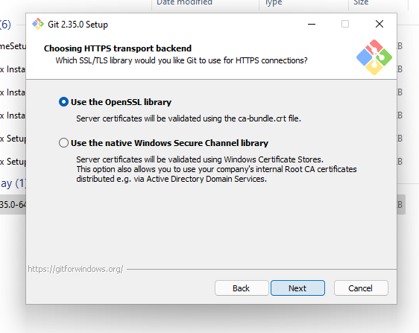

* Click on 'Next' Button. After that 'Configuring the line ending conversions' windows will be opened.

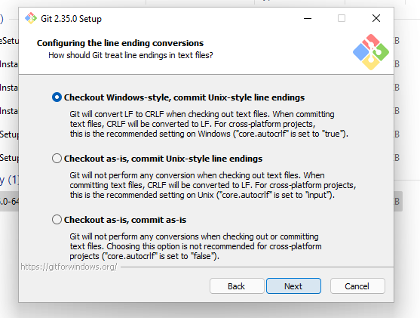

* Click on 'Next' Button. After that 'Configuring the terminal emulator to use with Git Bash' windows will be opened.

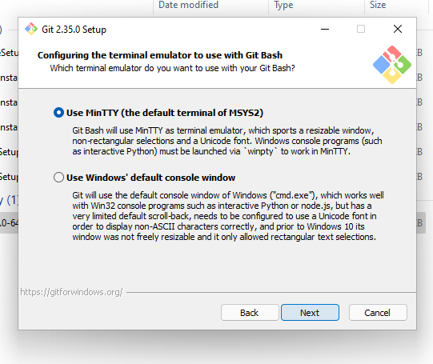

* Click on 'Next' Button. After that 'Choose the default behaviour of 'git pull' 'windows will be opened.

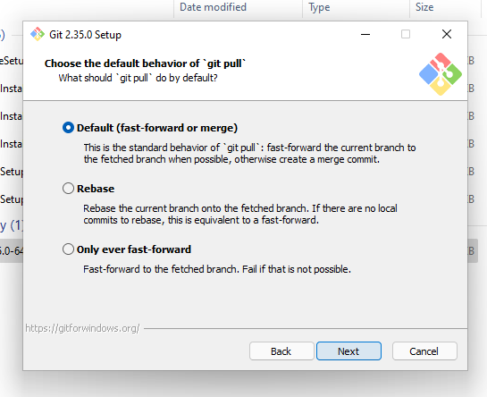

* Click on 'Next' Button. After that 'Choose a credential helper 'windows will be opened.

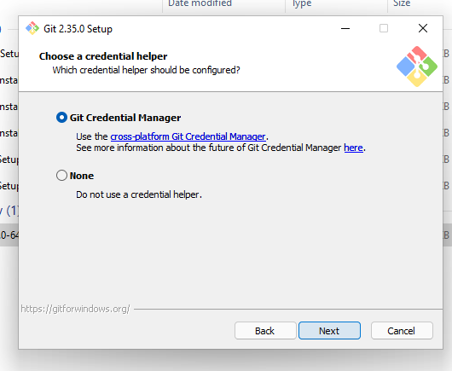

* Click on 'Next' Button. After that 'Configuring extra options' windows will be opened.

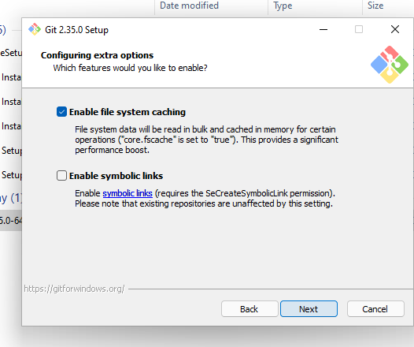

* Click on 'Next' Button. After that 'Configuring experimental option' windows will be opened.

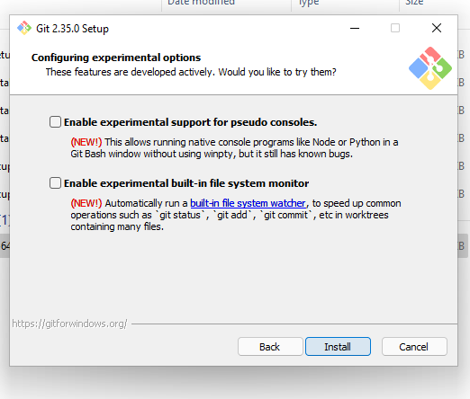

* Click on 'Install' Button. After that installation will be completed.

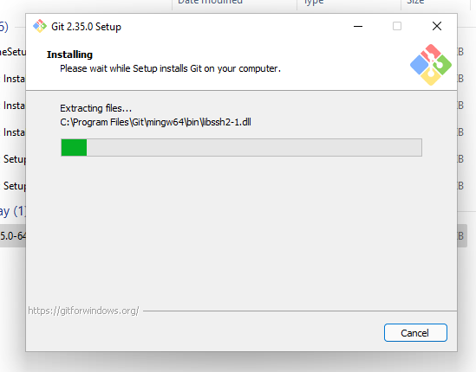

## **Verification:**

* + - Log in to the machine where Git has been installed.
    - Open 'Control Panel'.
    - Navigate to 'Programs\Programs and Features'.
    - 'Git' must be present in the installed software list.

